THE FOSSILIZATION AND COLLECTION OF DINOSAURS

Preparing and Analyzing Fossils

by Sunny Hwang
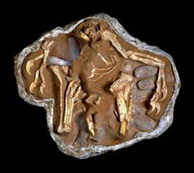
A large amount of sediment—surrounding the bones, in addition to the remains of the plaster jacket—provides support for this specimen of an oviraptoridbrooding a nest while preserving its original orientation. ©AMNH

Finding and collecting fossils in the field is only part of the job. Once you’ve found a specimen, you don’t really know what you’ve found until you’re back in the laboratory, where the preparation of the specimen and an analysis take place.
As you have learned, often only a small part of a fossil is exposed in the field. Usually a good amount of the rock surrounding the fossil, which is called the matrix, is collected along with the fossil itself. This matrix needs to be removed, and the fossil needs to be strengthened against future damage. This process is called preparation.
Preparation, or “prep” for short, is more often than not a slow and painstaking process that sometimes takes years. Because fossilized bone is often more delicate than the surrounding rock, you have to work very slowly and carefully so that you don’t break or chip the fragile fossil.

Preparation
When a specimen arrives from the field, the plaster field jacket in which it may have been wrapped is cut open with a plaster saw. This is the same kind of saw doctors use to cut open the plaster casts wrapped around broken limbs. Some fossils may arrive simply embedded in a rock slab without a jacket, or as bones completely free of a matrix. The matrix is then scraped away, using whatever tools are most suited to the job. The best tool to use depends on the type of rock the fossil is embedded in, the size of the fossil, and the kinds of tools you have on hand. Wooden scrapers similar to popsicle sticks, metal picks like ice picks, and dental tools are used for delicate prep work. Power tools, like mini-jackhammers, are used to remove larger amounts of rock quickly. They are harder to control than non-power tools, so they are only used when you have large sections of the matrix to remove. For very delicate bones, sometimes only a paintbrush dipped in water is used to wipe the rock away. The loosened rock is blown away, brushed off with dry paintbrushes, or vacuumed if there is a large amount of it. Glue or some other hardening agent is poured, or painted, on the bone as it is exposed, so that it becomes more resistant to damage. Glue is also used to reattach any broken pieces.
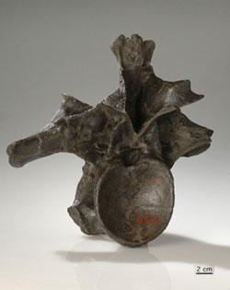
This vertebra from an Allosaurus—catalogue number AMNH 666—are completely prepped; the entire matrix has been removed for a complete view of the bones. ©AMNH

Some bones are removed completely from the rock, while some are left partially exposed. Depending on how the bones will be used for study, it might be favorable to maintain the orientation of the skeleton in the rock, or if anatomical studies are planned, it might be favorable to see the entire bone. Decisions about how best to prepare the specimen are continuously made during the preparation process, as more and more of the specimen is uncovered. If only some parts of a skeleton need to be seen, then the preparator exposes only those specific parts. There are several advantages to only partially prepping a specimen.
- The specimen is less likely to be broken, as the bones are partially supported by the surrounding rock.
- You can see the original three-dimensional orientation of the skeleton because the bones have not been separated.
- It takes less time.

Identification
Once the specimen has been prepared, the next step is to identify the bone or bones in the fossil specimen. This includes what part of the body the bone came from and the kind of animal it came from. When in the field, paleontologists can make educated guesses about the kind of animal the bone might be from, but no one knows for sure until they are back in the lab.
Identification can either be relatively easy or very hard to do. It’s easiest when the fossil find is a complete, articulated skeleton (where the bones are in their correct positions), but this is very rare. Most of the time, paleontologists find only a few bones from a single animal, and these bones are often just fragments. When bones are not in their proper context, it’s much harder to identify them. But there is a systematic method paleontologists use to begin to identify these bones. Paleontologists obviously can’t memorize every single bone that’s ever been found for every single organism. This is where institutional collections and other kinds of documentation, like pictures of specimens, come in. First off, we know that because all dinosaurs descended from a common ancestor, the major bones in all dinosaurs have the same general shape. If you’ve seen one femur or one humerus, you’ve basically seen them all. This skeletal similarity among all dinosaurs is what enables paleontologists to recognize the part of the body to which the bone belongs.
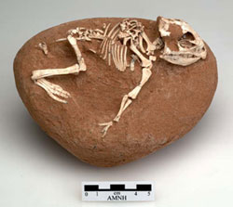
This baby Protoceratops skeleton from Mongolia has been prepped just enough to see the majority of the specimen, while the surrounding matrix still supports and maintains the skeleton’s natural orientation. ©AMNH
Figuring out the kind of dinosaur a bone comes from is more difficult. Dinosaurs belonging to the same family have very similar bones, and it is often only three or four unique anatomical characteristics or skeletal features that distinguish one species in a family from another. In cladistics, these unique characters are called diagnostic characters, because they help you diagnose or recognize a group (e.g., genus, species) very specifically. So even if paleontologists have found a perfect, whole, undamaged bone, it may not help them identify the group that they have if it doesn’t have any of the unique characters. For example, finding a toe claw may tell paleontologists that they’ve found a theropod claw, and its giant size might tell them that it’s from a tyrannosaurid, but it won’t tell them what species of tyrannosaurid. To help them identify fossils as specifically as possible, paleontologists compare the bones they have recently found to bones already present in their institution’s collections or to published pictures of other specimens, to see if they match those of any known species.

Analysis
Although it may seem too simple, a lot of information can be gathered from a fossil by making careful, detailed observations. For example, the general age of an animal (whether it was young or old) and some diagnostic characters (such as the presence of openings in the skull) can be determined with a thorough examination of the external features of a fossil. Fossils of theropod dinosaurs are relatively rare, so most paleontologists are reluctant to sacrifice a bone (e.g., by cutting out a thin section of the bone to look at under a microscope) even if it means they could learn a great deal more.
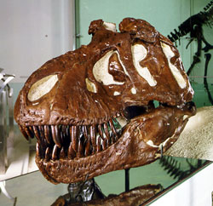
This T. rex skull is supported from within by the matrix that entombed it for 65 million years. ©AMNH Library
If paleontologists are willing to sacrifice part or all of a specimen, then there are several techniques and tools they can use to find more information. One technique is to slice off sections of bone so thin that light can pass through them to use a light microscope. This allows you to study the internal and microscopic structure of the bone. Another technique is to grind up small pieces of the bone and conduct a chemical analysis that will tell you the chemical composition of the fossil and whether any biomolecules had been preserved. A more recent, non-destructive technique is to use CAT scanning. Although not used frequently, this technique often allows you to see the internal structure of the bone without damaging the specimen. The CAT-scan images can also be compiled into a three-dimensional model. Scientists can digitally manipulate the model to examine previously inaccessible areas of a specimen (e.g., the inside of a skull or nasal passage). At the same time, there is considerable expense to CAT scan a fossil and because there are limits to the technology. For example, if the mineral composition of the fossil and surrounding matrix are similar the CAT scan isn’t always able to differentiate between the two.
If the bone(s) discovered belongs to a previously undescribed group or forms a more complete specimen of an already discovered and described group, then paleontologists publish their descriptions to make them available to the larger scientific community. The unique characters that were observed and described in the specimen also help paleontologists complete cladistic studies and determine the relatedness of the group to other known groups.

Related Links
Fossil Preparation and Conservation »
Fossils are preserved in many different ways. This site provides a "how-to" using a number of the materials and techniques of fossil preparation.
The Jigsaw Fossil »
Archaeoraptor, found in the mid-1990s, was thought to be the missing link between dinosaurs and birds. Conclusive evidence now points to the fact that the specimen is a forgery?actually a composite of two different dinosaur skeletons. Read more at this Scientific American site.

