THE FOSSILIZATION AND COLLECTION OF DINOSAURS

How to Collect Fossilized Dinosaurs

by Diego Pol
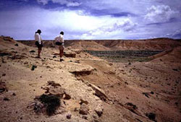
Much time on paleontological expeditions is spent prospecting: hiking around likely exposures, and scanning them for bits of eroding fossils. ©AMNH
There’s a certain amount of romance associated with the collection of dinosaur fossils. As we learned earlier, to find great dinosaur fossils means that we must find good places to look for them. This is only the first part of the process. Once you’ve found a fossil, what do you do with it? How do you begin to understand and examine the evidence? The answer, in part, depends on where you are.

The Prospecting and Jacketing Collection Method
For the past 11 years, members of the Museum’s Department of Vertebrate Paleontology have gone to a unique place to collect dinosaur fossils: the Gobi Desert in Mongolia. The expedition team knows from geological studies and previous expeditions several places that are likely to be good fossil-hunting spots in the Gobi. The aim is to find places where Late Cretaceous (approximately 98-65 mya) rocks are exposed. There are plenty of them in the Gobi Desert. The Gobi is extremely fossiliferous, and several amazing fossil theropod specimens have been collected there.
Once the team arrives at the site, they look for small fragments of bone that are exposed on the ground. This is usually easier said than done, but with luck and a bit of experience, the team finds them. And if they’re really lucky, one of these fragments could be the first exposed part of a skeleton where the bones are still associated with one another in a lifelike manner. When a fragment of bone is found on the ground, a close and careful examination is done in order to determine if this is an isolated fragment, or if more skeletal remains are associated with it. The team will usually look uphill to try and find the source of the bone, since the first fragments of bone are likely to fall downhill after they break from a skeleton.
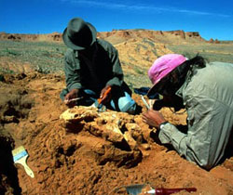
Once a fossil is found, the next step is to determine its size and expanse through careful excavation. ©AMNH

If the bone found is just a fragment, then it may be either collected or discarded. If you can tell it is from a rare animal, and if the site you’re collecting in only has bone fragments, then you might collect the specimen. It all depends on what you’re looking for, the condition of the bone, and the rarity of the specimen. If it appears that the bones are part of a larger skeleton, the first step is to figure out how much of the specimen is preserved and the way the remains are located in the rock. This needs to be done while exposing the least possible amount of bone surface. Brushes, dental picks, knives, and small chisels are some of the tools used for this job.
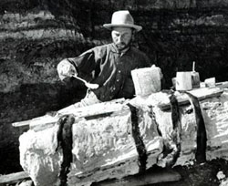
The basic technique for protecting large fossils for transport— jacketing—has remained relatively unchanged for over a century. ©AMNH Library

As much of the bone as possible is left within the rock because separating the fossil from the rock is a job that is better done carefully in the lab, where the many painstaking hours necessary to clean the fossil can be spent. The other reason the lab is preferable for this type of work is that you are not constrained by inclement weather, time, and tools. If the team is lucky, it might find a complete dinosaur skeleton. Since fossils are extremely delicate, several chemical products are used to harden the bones for preservation. Without these glues, the fossil could be completely destroyed during the extraction.
The next step is to extract the skeleton from the rock. This is a two-step process. First, the rock surrounding the fossil is cut away, leaving a block of sediment, called a pedestal, which contains the skeleton, surrounded by a trench. This is a long and hard task that can take several days of work, depending on several factors such as: the size of the fossil, the hardness of the rock it is embedded in, and the amount of sediment that overlies parts of the skeleton. Once the skeleton is isolated in the pedestal, the second phase of the extraction can begin.
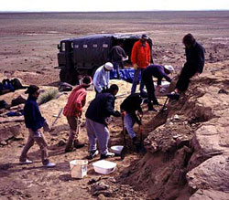
One of the best places to look for dinosaur fossils is in the desert where access to sites is difficult. On a 1999 Gobi Desert expedition, several team members prepare to move a specimen into a large four-wheel drive vehicle to transport back home. ©AMNH
The second step of the process is to make a plaster jacket that will protect the fossil as it is transported from the field to the lab. First, a layer of toilet paper or aluminum foil is carefully laid to cover the exposed bones and to conform to the contours of the specimen. This layer is added to protect the bones from the plaster jacket, which has a tendency to adhere to the specimen and damage it if it is removed without a protective layer. Then, several successive layers of plaster are applied to the top and the sides of the pedestal. The thick plaster jacket must set completely before it is moved.
The next step is the most nerve-racking—separating the plaster jacket containing the fossil from the rest of the rock. The bigger the plaster jacket, the harder this is to do. Extracting large plaster jackets might require several people working together, and a great deal of effort. The first thing to do is to weaken the attachment of the pedestal by digging out sediments from its base. Once the jacketed part is loose, the action can start. The jacket must be turned upside down quickly, smoothly, and safely. The base of the jacket is then covered with plaster to fully protect the fossil. When the plaster sets, the jacket is labeled with the date, locality, and an identification number, and is carried to the vehicle (which can also be a pretty hard job!).

The Quarry Collection Method
Although the prospecting and jacketing collection method described above is useful for an area that contains few fossils, sometimes as you prospect an area, you realize that a particular stratigraphic layer of rock has an extremely high abundance of fossils. In this case, you would switch to a quarry collection strategy, because it is a more systematic and controlled method of removing large amounts of rocks and assessing their fossil content.
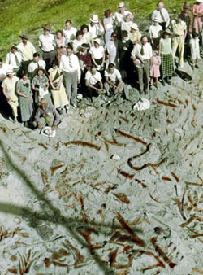
Howe Quarry, Wyoming, excavated by AMNH scientists in the 1930s, contained a huge bed of Jurassic sauropod bones. ©AMNH Library
Once an area is found suitable for the quarry method, you usually remove all the rock above the fossil-rich area (sometimes using earth-moving equipment). This extra rock is called overburden. Then you carefully take out a certain unit of sediment (anywhere from a few millimeters deep to a few inches) and break up these rocks to look for fossils.
One site where this method is currently used is the now famous beds of Liaoning Province in China, where several feathered, non-avian dinosaur specimens have been found during the last few years. Since these specimens are exceptionally well preserved (complete skeletons with feather impressions), it is worthwhile to open a big quarry. Hundreds of people usually work in this type of quarry. The hard and long job seems justified when such spectacular specimens are discovered.

